**Gold Stag Head Vintage Wall Mount**

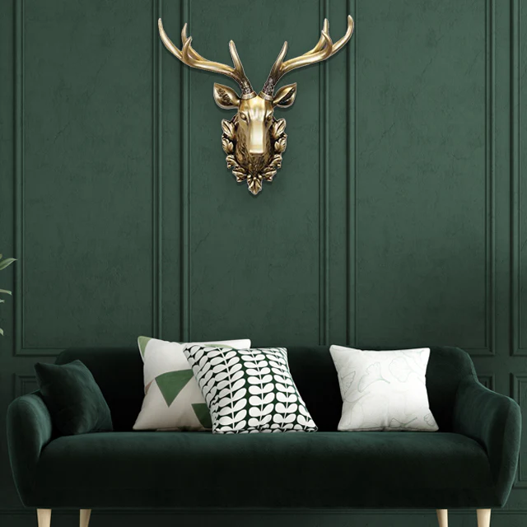A gold stag head vintage wall mount is a luxurious and timeless piece of decor that brings a touch of regal charm and rustic elegance to any space. Crafted with intricate detailing to capture the majestic features of a stag, the shimmering gold finish enhances its opulent appeal while evoking a sense of classic sophistication. Often made from durable materials like resin or metal, this wall mount serves as a captivating focal point in living rooms, dining areas, or entryways. Perfect for vintage, eclectic, or traditional interiors, the gold stag head symbolizes strength and grace, making it a statement piece that transforms any wall into an artful display.